This is the code I wrote to cause a memory leak problem:
#include <stdio.h>
#include <stdlib.h>
#include <string.h>

int main()
{
size_t size = 1024 * 1024 * 50; // Allocate 50MB per iteration
int block = 0;
void *p;

while(1)
{
p = malloc(size); // Allocate memory
if (p == NULL) {
printf("Memory allocation failed after %d iterations, approx %.2f GB allocated.\n", block, (block * size) / (1024.0 * 1024.0 * 1024.0));
break;
}
else {
// Displaying memory allocation in MB rather than GB
printf("Iteration: %d, Total Memory Allocated: %.2f MB\n", block + 1, (block + 1) * size / (1024.0 * 1024.0));
}

block += 1;
}

return 0;
}

I have run my code on an AZURE VM.
From what I observed while running the program, the memory usage started at around 4.6 GB and increased to 11.3 GB by the time the program got terminated. That means the program used approximately 6.7 GB of additional memory during the 176 iterations. Each iteration allocated 50 MB, which adds up to roughly 8.8 GB of allocated memory, but due to system overhead, the actual increase in memory usage was about 6.7 GB.

The physical address space of the Azure Lab machine I'm using is 16 GB of RAM, and the system is 64-bit, which means it has a much larger logical address space, theoretically up to 16 exabytes, though the available physical memory constrains it.

This is before I ran the code:
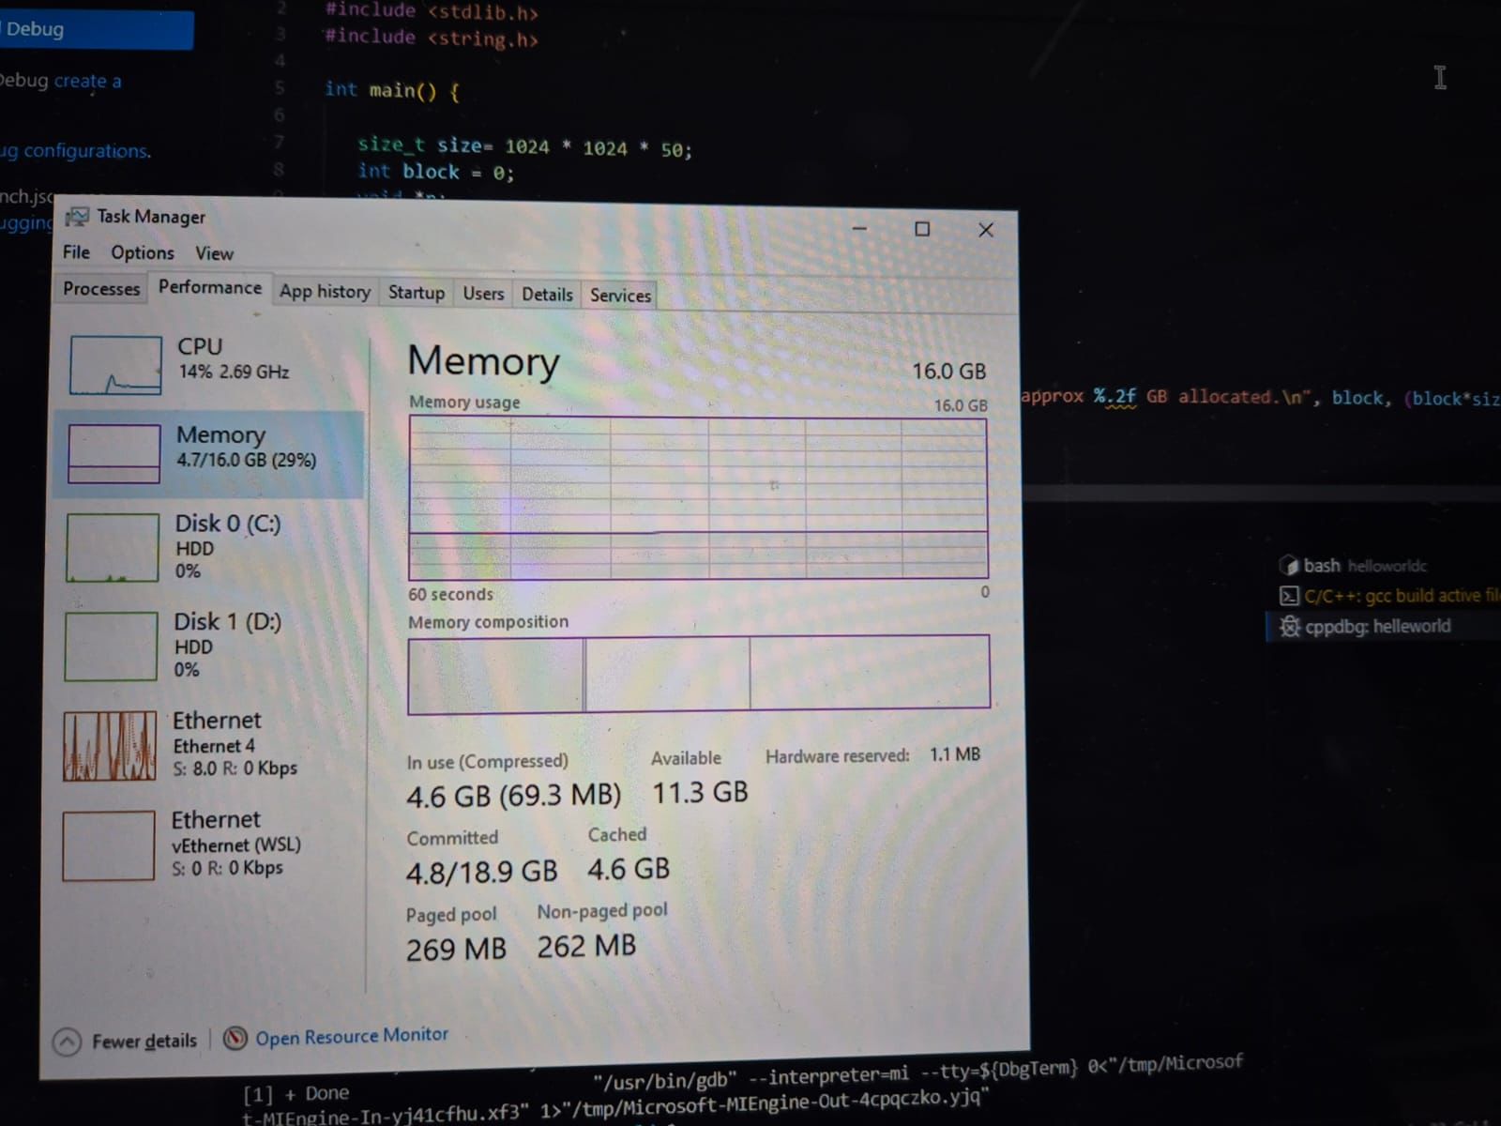
This is after I ran the code:
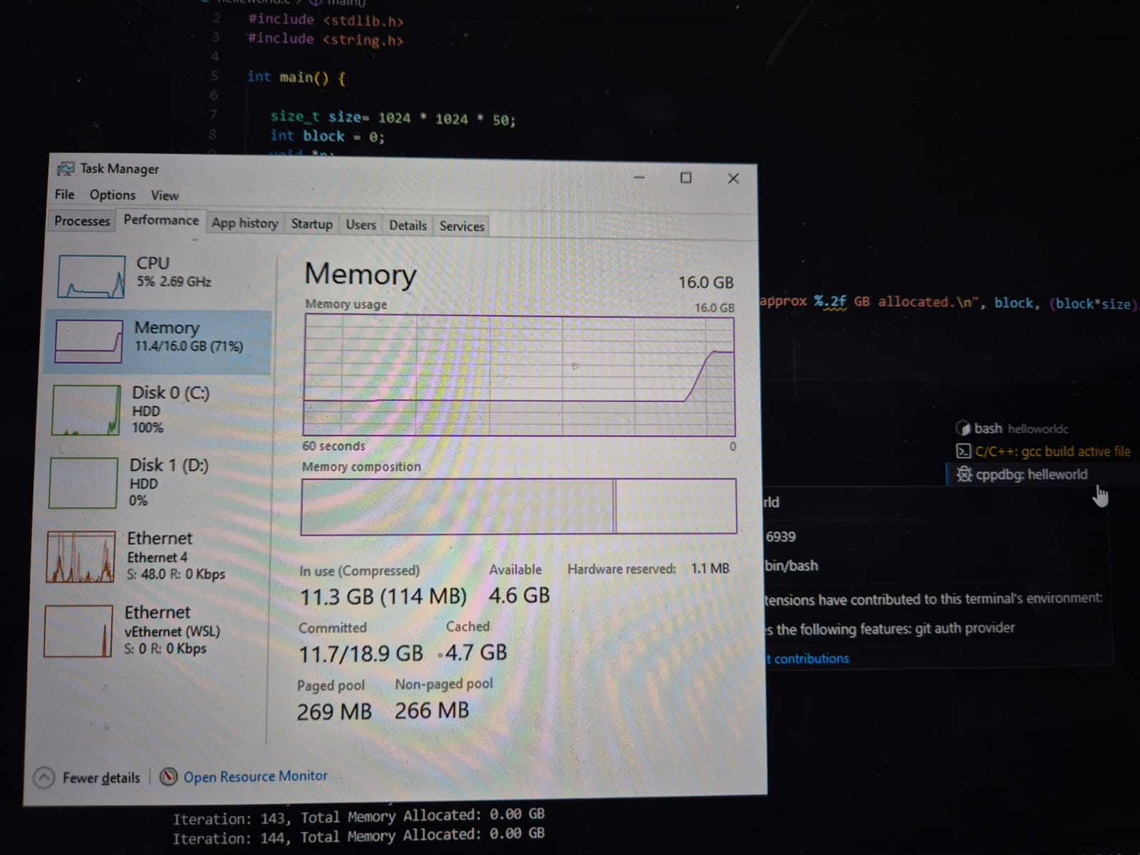

From my understanding, the virtual memory is exhausted when the program runs into a memory leak issue. This is because the system starts using both physical memory (RAM) and virtual memory (swap space) to handle the memory allocations. As the program keeps allocating more memory without freeing it, the system runs out of virtual memory resources, and that's when the memory allocation fails.

---

When my program consumed a significant portion of memory, I noticed that the system slowed down considerably. This is because, once physical memory is exhausted, the system starts relying on swap space, which is much slower. During this process, other programs might have trouble starting or running effectively due to the lack of available memory. The entire system slows down because it’s constantly swapping memory pages between RAM and disk, leading to performance issues.

---

In platforms like .NET and JVM, the memory leak problem can be largely avoided because of garbage collection (GC). In my case, I was manually allocating memory in C, which means if I forget to free the memory, it leads to a leak. However, in managed environments like .NET and JVM, garbage collectors automatically identify unused objects and free up memory, which reduces the risk of leaks. This is a huge advantage because developers don't have to manually manage memory, which is error-prone.

---

